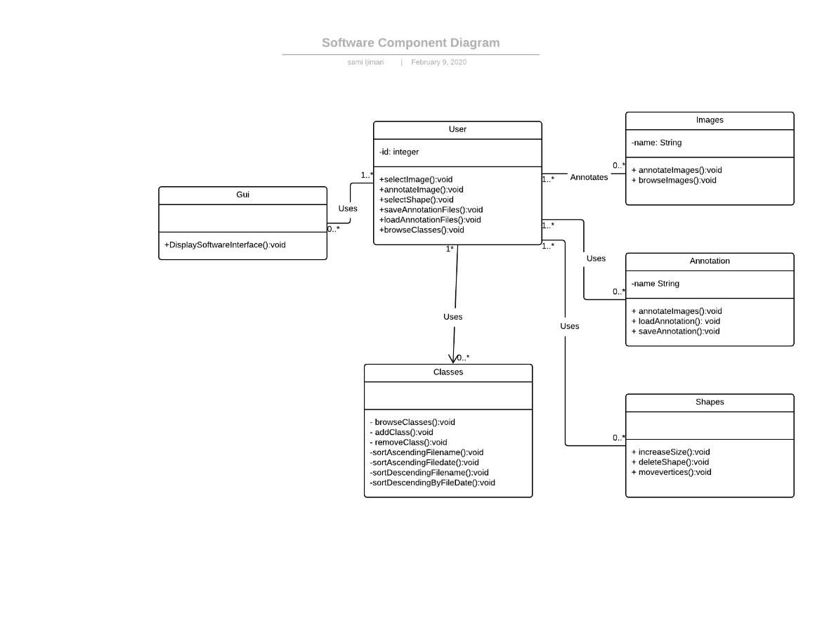

Diagram depicts the labelling software’s class diagram. 6 Class shapes have been added to represent the 6 classes identified by our team for the system. First Class the Gui contains no attributes and one function called displaysoftwareinterface():void and is used by the User Class. The user class contains id attribute as well as selectImage():void +annotateImage():void +selectShape():void +saveAnnotationFiles():void +loadAnnotationFiles():void +browseClasses():void functions. Classes Annotation, Shapes and Classes are used by the user along with their respective functions. Images class is annotated by the user.s

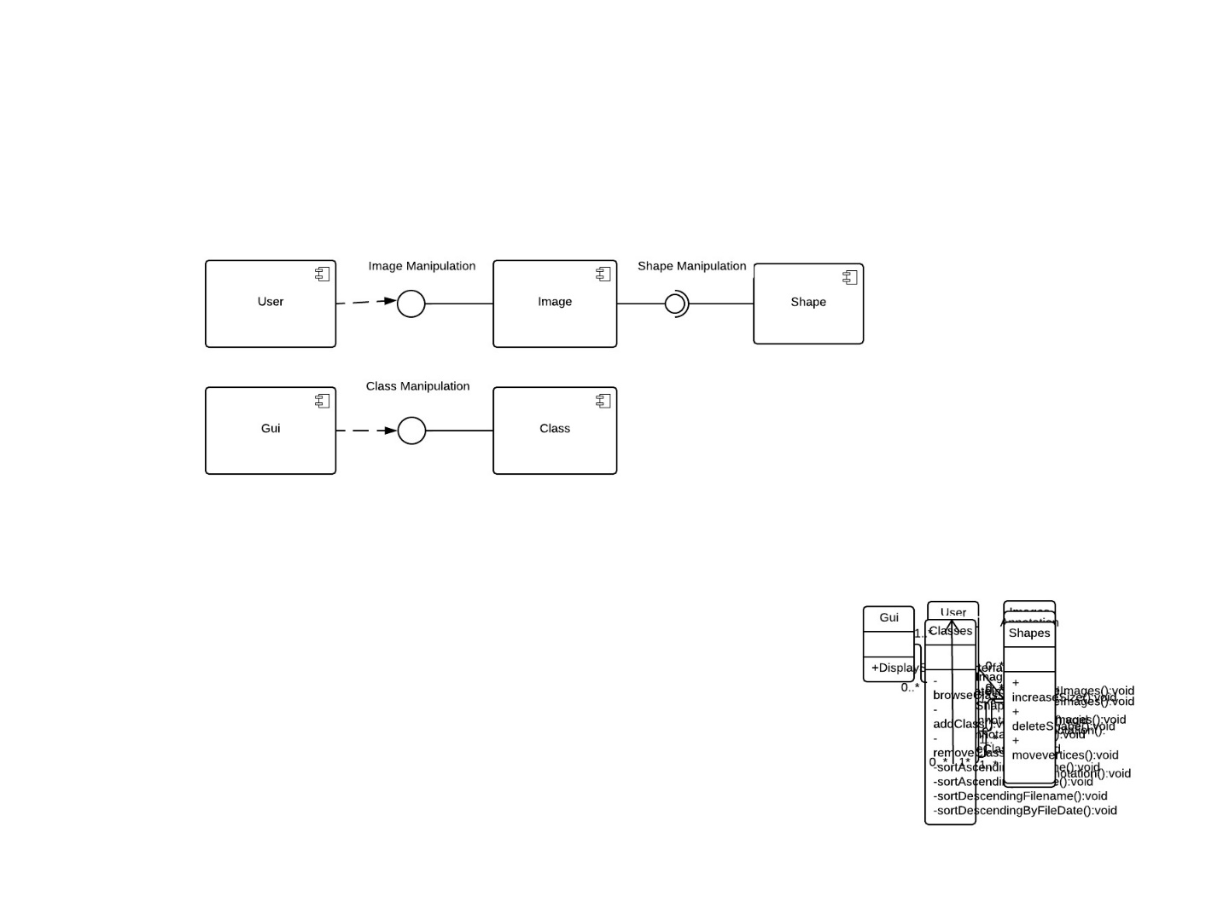

Diagram depicts the labelling software’s component diagram. Diagram contains depiction of 5 components which are user, GUI , Image , Class and shape component. Dependency symbol serves to demonstrate the user and GUI´s dependencies on both the image and the class component. Image component provides image manipulation interface while class component provides class manipulation interface. Shape component requires shape manipulation interface while the same interface is produced by the image component